Coaxial Swerve Drivetrain Pod
Design & Hardware - Drivetrain Subsystem

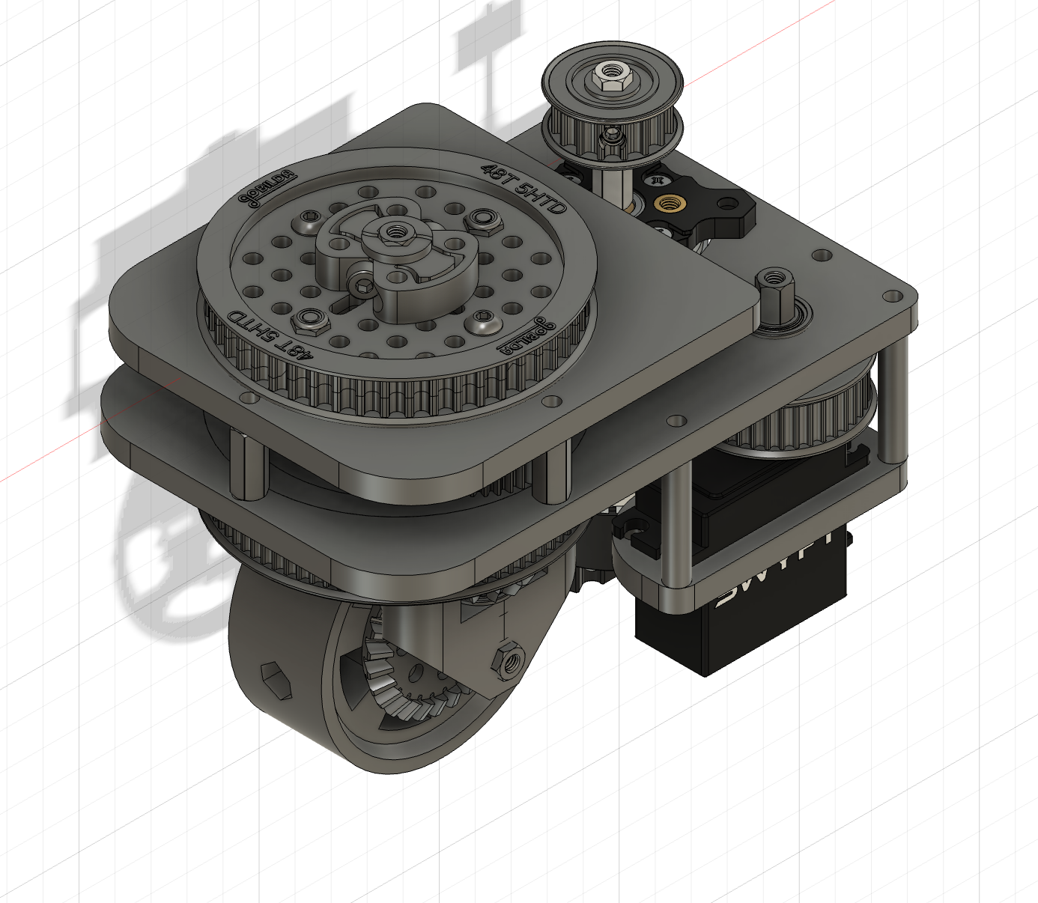

Each pod of the drivetrain is a steerable drive module that lets a single wheel rotate in any direction while driving, achieving holonomic motion. The assembly packages the hardware between two plates to stay compact and rigid, with the steering handled by a belt driven pulley system, and drive routed through bevel gears and pulleys down to the wheel.

Frame & Structure
The pod is built on a sandwiched two-plate aluminum frame joined by standoffs. Stacking the plates on standoffs sets a gap for the steering and drive components, and gives the module stiffness without adding a heavy enclosure around it. All mounting uses the goBuilda hex hole/bore pattern, which keeps the plate layout, pulley mounting, and motor placement on a consistent grid.

Steering
The steering runs on a 81-tooth custom designed pulley that forms the rotation ring. A SWYFT motor drives this ring through a 5 mm HTD timing belt. The HTD belt was chosen over a geared ring for lower friction, quieter steering and simpler tensioning; keeping the belt under tension is what limits backlash.

Drive
Drive power comes from a separate drive motor and is transmitted down through a pulley system and bevel gear set to the wheel. Routing the drive along the rotation axis keeps the drive path separate from steering, so rotating the module does not disturb wheel speed.

Key Specifications

Steering actuator | SWYFT servo
Steering ring | 81 tooth custom designs pulley
Steering reduction | 2.7:1
Drive motor | goBuilda bare motor with built in hex shaft
Drive transmission | Pulleys, and bevel gear set
Drive reduction | 10.8:1 555 RPM
Wheel | 72 mm / metal casted
Tread | Andimark Blue Nitrilite
Frame | Two-plate aluminum on standoffs
Primary hardware | goBuilda structural & motion components
Pods on robot | 4

